**User Documentation**

**Dino Runner Game**

Dino Runner is a simple 2D side-scrolling game where the player controls a dinosaur character to avoid obstacles and birds. The player can make the dinosaur jump and shoot rockets to eliminate flying birds.

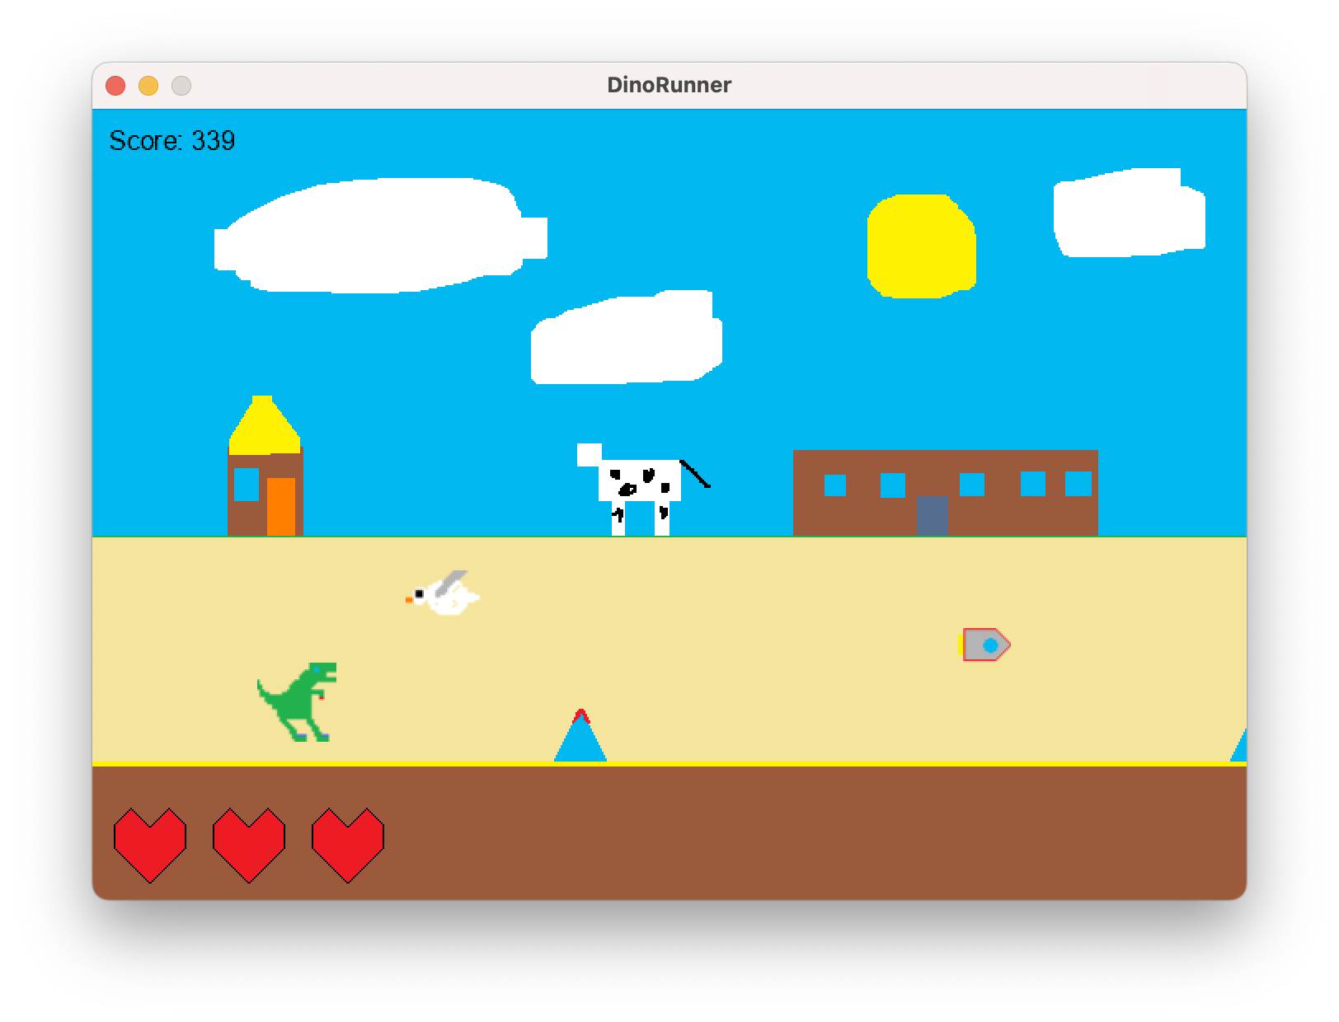

**How to Play**

1. Press Enter to start the game.
2. Press Space to make the dinosaur jump.
3. Press F to shoot rockets.
4. Avoid colliding with obstacles and birds.
5. The game ends when the dinosaur loses all its health or collides with an obstacle/bird. Press R to restart the game.

**Scoring**

The player's score increases as they progress in the game. The game speed also increases with the score.

**Technical Documentation**

This section provides an overview of the game classes and their main responsibilities.

**Program.cs**

This class contains the main entry point of the game. It initializes and runs the game.

**Game1.cs**

This class is the main game class and is responsible for managing game states, loading content, updating game logic, and drawing game objects.

**Properties and Fields**

* _**graphics**: Graphics device manager.
* _**spriteBatch**: Sprite batch used to draw textures.
* _**gameSpeed**: The speed of the game.
* _**gameScore**: The score of the game.
* _**player**: The player object.
* _**ground**: The ground object.
* _**obstacles**: List of obstacle objects.
* _**birds**: List of bird objects.
* _**obstacleSpawnTimer**: Timer to control obstacle spawning.
* _**obstacleSpawnInterval**: Interval between obstacle spawns.
* _**birdSpawnTimer**: Timer to control bird spawning.
* _**birdSpawnInterval**: Interval between bird spawns.

**Methods**

* **Initialize**(): Initializes the game state, obstacles, and birds.
* **LoadContent**(): Loads game content such as textures, fonts, etc.
* **UpdateObstacles**(GameTime): Updates obstacles and checks for collisions with the player.
* **UpdateBirds**(GameTime): Updates birds and checks for collisions with the player.
* **CheckRocketBirdCollisions**(): Checks for collisions between rockets and birds.
* **Update**(GameTime): Updates game logic based on the current game state.
* **Draw**(GameTime): Draws game objects and UI elements.

**Player.cs**

This class represents the player's dinosaur character.

**Properties and Fields**

* _**playerState**: The current state of the player (waiting, running, jumping, or dead).
* _**waitingTexture**, _**runningTexture1**, _**runningTexture2**, _**deadTexture**: Textures for different player states.
* _**currentTexture**: The texture currently being displayed.
* _**position**: The position of the player on the screen.
* _**velocity**: The player's velocity.
* _**rocketTexture**: The texture for the rocket.
* **Rockets**: List of rockets fired by the player.
* **Health**: The player's health.
* _**heartTexture**: The texture for the player's health icon.

**Methods**

* **Collide**(): Handles player collision with obstacles or birds.
* **Update**(GameTime): Updates the player's state and position.
* **Shoot**(GameTime): Shoots a rocket if the player is not dead and the cooldown has expired.
* **Draw**(SpriteBatch): Draws the player and its rockets.

**Rocket.cs**

The **Rocket** class represents a rocket object in the game. It has a position, a texture representing the rocket image, and a speed.

**Properties**

* **Position**: A **Vector2** representing the rocket's position on the screen.
* **Bounds**: A **Rectangle** representing the rocket's bounding box, used for collision detection.

**Constructor**

* **Rocket**(**Texture2D** texture, **Vector2** position): Creates a new **Rocket** object with the provided texture and position.

**Methods**

* **Update**(GameTime gameTime): **Updates** the rocket's position based on its speed and the elapsed game time.
* **Draw**(SpriteBatch spriteBatch): **Draws** the rocket on the screen using the provided sprite batch.

**Bird.cs**

The **Bird** class represents a bird object in the game. It has position, two textures for animating the bird's flight, and an animation timer.

**Properties**

* **Bounds**: A **Rectangle** representing the bird's bounding box, used for collision detection.
* **Position**: A **Vector2** representing the bird's position on the screen.
* **Width**: A **float** representing the width of the bird texture.

**Constructor**

**Bird**(**ContentManager** content, **Vector2** position): Creates a new **Bird** object with the provided content manager to load textures and the initial position.

**Methods**

* **Update**(**GameTime** gameTime, **float** speed): **Updates** the bird's position based on the provided speed and updates the animation timer based on the elapsed game time.
* **Draw**(**SpriteBatch** spriteBatch): **Draws** the bird on the screen using the provided sprite batch, animating between two textures.
* **UpdateAnimation**(**GameTime** gameTime): **Updates** the bird's animation, toggling between two textures based on the animation timer.

**Obstacle.cs**

The **Obstacle** class represents an obstacle object in the game. It has a position and a texture representing the obstacle image.

**Properties**

* **Bounds**: A **Rectangle** representing the obstacle's bounding box, used for collision detection.
* **Position**: A **Vector2** representing the obstacle's position on the screen.
* **Width**: A **float** representing the width of the obstacle texture.

**Constructor**

* **Obstacle**(**ContentManager** content, **Vector2** position, **int** obstacleType): Creates a new Obstacle object with the provided content manager to load the texture, initial position, and obstacle type.

**Methods**

* **Update**(**float** speed): **Updates** the obstacle's position based on the provided speed.
* **Draw**(**SpriteBatch** spriteBatch): **Draws** the obstacle on the screen using the provided sprite batch.

**Ground.cs**

The **Ground** class represents the ground in the game. It has a texture representing the ground image and a list of positions for ground tiles.

**Constructor**

* **Ground**(**ContentManager** content): **Creates** a new **Ground** object with the provided content manager to load the texture.

**Methods**

* **Draw**(**SpriteBatch** spriteBatch): **Draws** the ground on the screen using the provided sprite batch, with multiple ground tiles arranged horizontally.